# Student Musical Night 2024

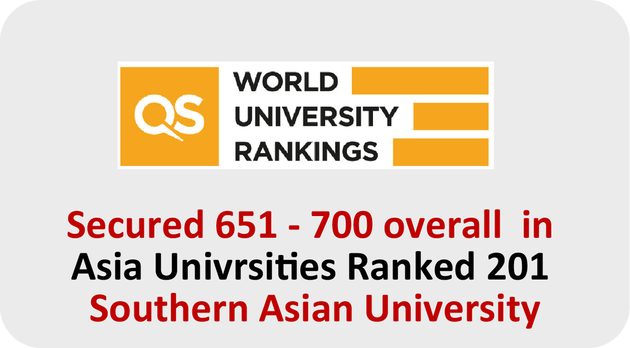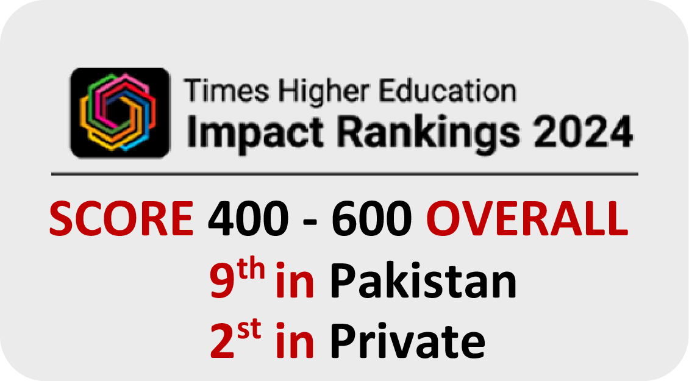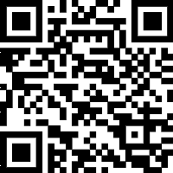

**Name :** ZOHAIB KHALID

**CNIC :** 3310075066379

**Contact :** 03124721951

The University of Faisalabad, Canal Road, Faisal Town, Faisalabad.

# December

**Time :** 05:00 PM

**20**

**Registration #** : 2022-BS-SE-108

Canal Road, Faisal Town, Faisalabad.

c_fb0c461a-1274-46c1-8926-aecbb96738cf